Title: Online Train Reservation System
Aim
To develop a web-based Train Reservation System that allows passengers to search trains, check seat availability, book and cancel tickets, check PNR status, and receive refunds.
Algorithm
- Start the application.
- Allow passengers to register and log in.
- Enter journey details and search for trains.
- Display available trains, seats, and fares.
- Enter passenger details and complete payment.
- Generate the ticket and PNR number.
- Allow passengers to check PNR status and cancel tickets.
- Calculate refunds and allow the admin to manage train details.
- Stop the application.
HTML Code

<!DOCTYPE html>
<html lang="en">
<head>
<meta charset="UTF-8">
<meta name="viewport" content="width=device-width, initial-scale=1.0">
<title>Train Reservation System</title>
<style>
body { font-family: Arial; background: #f0f4f8; margin: 0; }
header { background: #174a72; color: white; text-align: center; padding: 20px; }
main { max-width: 550px; margin: 25px auto; background: white; padding: 20px; }
input, select, button { width: 100%; padding: 10px; margin: 8px 0; box-sizing: border-box; }
button { background: #087f8c; color: white; border: none; cursor: pointer; }
footer { text-align: center; padding: 15px; }
</style>
</head>
<body>

<header>
<h1>Train Reservation System</h1>
<p>Search and Reserve Train Tickets</p>
</header>

<main>
<h2>Search Trains</h2>

<form id="trainForm">
<label for="from">Origin Station:</label>
<input id="from" required placeholder="Enter origin">

<label for="to">Destination Station:</label>
<input id="to" required placeholder="Enter destination">

<label for="date">Journey Date:</label>
<input id="date" type="date" required>

<label for="classType">Class:</label>
<select id="classType">
<option>Sleeper</option>
<option>AC 3 Tier</option>
<option>AC 2 Tier</option>
<option>AC First Class</option>
</select>

<button type="submit">Search Trains</button>
</form>

<div id="result"></div>

<h2>Check PNR Status</h2>
<input id="pnr" placeholder="Enter PNR number">
<button onclick="checkPNR()">Check Status</button>
<p id="status"></p>

<h2>Cancel Ticket</h2>
<input id="cancelPnr" placeholder="Enter PNR number">
<button onclick="cancelTicket()">Cancel Ticket</button>
<p id="cancelResult"></p>
</main>

<footer>
<p>&copy; 2026 Train Reservation System</p>
</footer>

<script>
document.getElementById("trainForm").onsubmit = function(e) {
e.preventDefault();

let from = document.getElementById("from").value.trim();
let to = document.getElementById("to").value.trim();
let date = document.getElementById("date").value;
let cls = document.getElementById("classType").value;

if (from.toLowerCase() === to.toLowerCase()) {
document.getElementById("result").textContent =
"Origin and destination must be different.";
return;
}

document.getElementById("result").innerHTML =
"<h3>Sample Train Details</h3>" +
"<p>Route: " + from + " to " + to + "</p>" +
"<p>Date: " + date + "</p>" +
"<p>Class: " + cls + "</p>" +
"<p>Available Seats: 25 (Demo)</p>" +
"<p>Fare: ₹500 (Demo)</p>" +
"<button onclick='alert(\"Demo only: no ticket booked.\")'>Book Ticket</button>";
};

function checkPNR() {
let pnr = document.getElementById("pnr").value.trim();
document.getElementById("status").textContent =
pnr ? "Demo: PNR status is not connected to a railway database."
: "Please enter a PNR number.";
}

function cancelTicket() {
let pnr = document.getElementById("cancelPnr").value.trim();
document.getElementById("cancelResult").textContent =
pnr ? "Demo only: ticket cancellation requires a booking system."
: "Please enter a PNR number.";
}
</script>

</body>
</html>
Output:
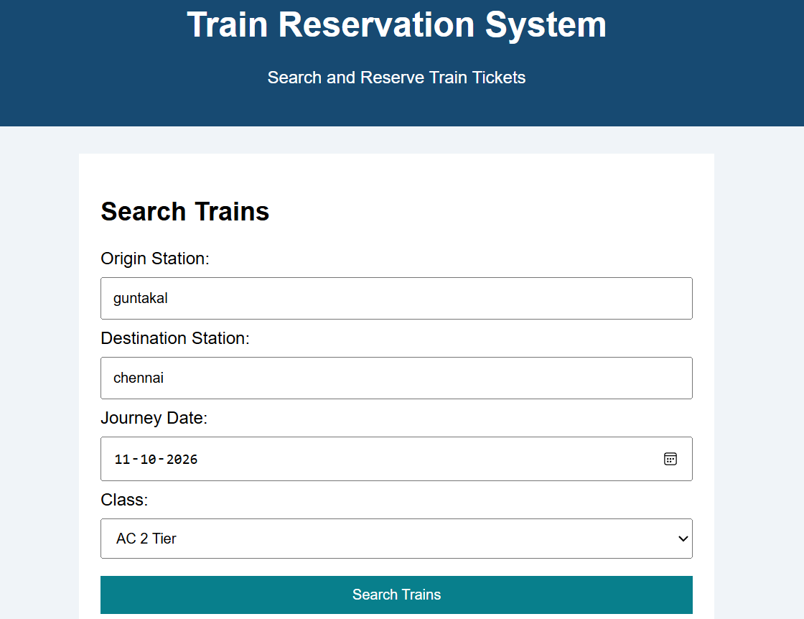
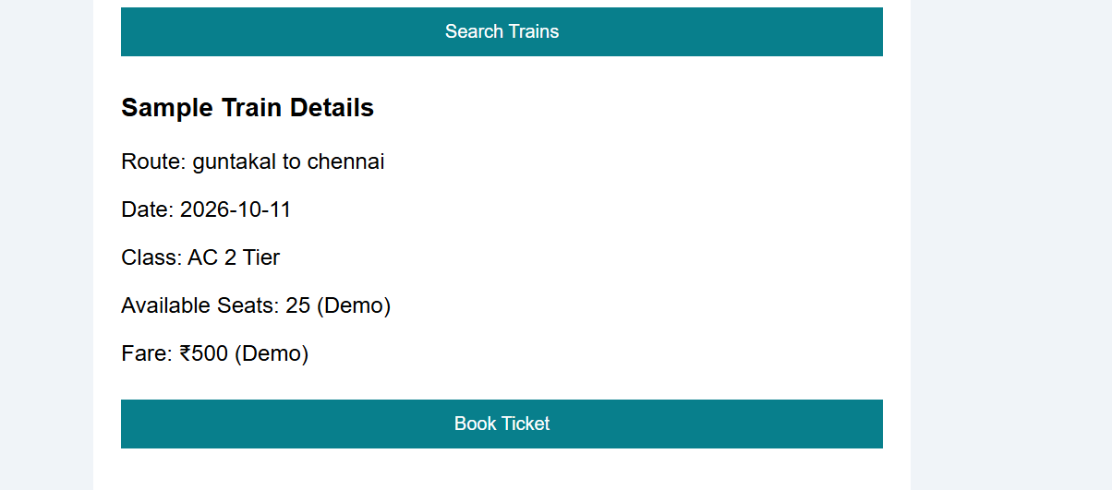
Result
The Train Reservation System webpage was created successfully. Users can enter journey details, search for sample trains, select a class, and enter a PNR number to access the demo status feature.

